GE ONBOARDING PROCEDURE:

- Physical ID access: Activate the ID card access for the respective GE location ODC you are working at. Connect with Manoj Godhwani (manoj.godhwani@capgemini.com) to get this done. He will work with ICRES ID cell of that location.

- Logical access: Once physical access is done, Manoj will coordinate with the logical access/Local IT team of the particular location.

- Once both the access is provided, connect with your manager for SSO ID creation.

- Raise a ticket in Service Central for installation of 3 GE applications. These apps will enable you to connect to GE VPN through the CG machine itself.

- F5 BIGIP Data client
- Forcepoint DLP
- Data classification tool

- To raise a ticket go to Service Central > Order or Request > Software Installation request
Fill up all the requested details and agree to the terms and conditions.
Mention to route the ticket to your respective location GE IT in the description
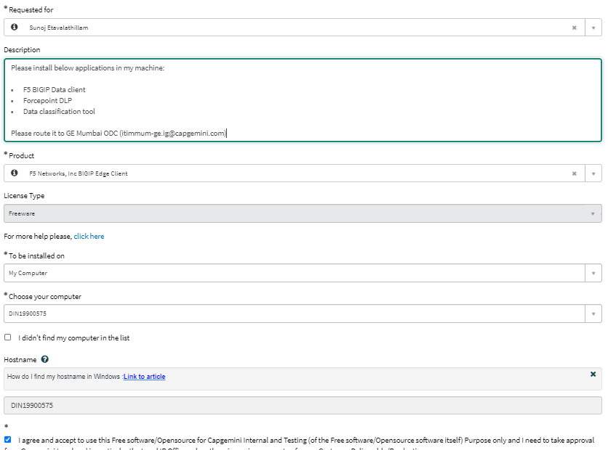

User facing any issue can raise request and contact Local IT or Global Help desk.
Location wise IT Team.
- Banglore: DL IG GE-BLR-IT ge-blr-it.ig@capgemini.com
- Hydrabad : DL IG ITIM-HYD-GE itim-hyd-ge.ig@capgemini.com
- Mumbai: DL IG ITIMMum-GE itimmum-ge.ig@capgemini.com
- Chennai: GroupIT OSS Chennai groupitgossindia-chennai-sipcot@capgemini.com
- Gandhinagar: Parikh,Nirajkumar niraj.parikh@capgemini.com

Please refer below email for further steps:

